**Curriculum Vitae _ Taqwa Altameemi**

**Personal Information**

Academic degree: **Lecturer**

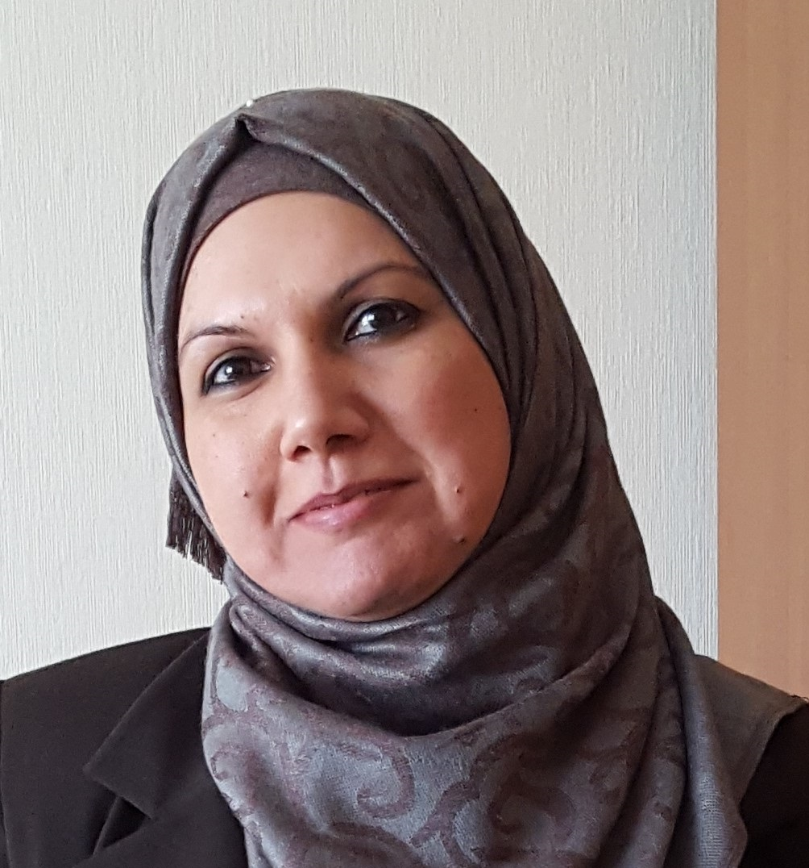

**Scopus ID: https://www.scopus.com/authid/detail.uri?authorId=5722252827**

**Researcher ID:** [F-1604-2016](https://publons.com/researcher/F-1604-2016/)

**ORCID :** https://orcid.org/0000-0001-9228-7106

h – Index: 5 calculated by Google Scholar

Birth Date & Place: April 26, 1975 – Iraq

Nationality: Iraqi

Mobile:

Email: [dr.taqwahasan_eng@uodiyala.edu.iq](mailto:dr.taqwahasan_eng@uodiyala.edu.iq) , [taqwa75@mail.ru](mailto:taqwa75@mail.ru)

And tota75m@yahoo.com

Website: [www.uodiyala.edu.iq](http://www.uodiyala.edu.iq)

Postal address: Department of Computer Engineering, College of Engineering, Diyala University, Baquba City, Diyala Governorate, ZIP 32001, Iraq.

**Professional Strength and Skills .**

* Very effective in Error correction code, Non Binary code, Cognitive Maps, Cryptography and Network Security , Computer Networks , MATLAB Programming ,Visual Basic6 ,C++ .
* Wide theoretical knowledge in most subject of Computer Science such as Computer Networks, Operating Systems, Information Theory, Data Structure, Software engineering, Programming Techniqes Microprocessor and Computers Security

**Educational Qualifications .**

* **Ph.D.** Modelling and complex programs - 2019 - Ulyanovsk state technical university - Russian Federation.
* **Ms. C.** Computer Science-2006 - Iraqi Commission for Computers and Informatics - Baghdad - Iraq.
* **B.Sc.** Computer Science - 1998 - University of Technology - Baghdad - Iraq.

**Memberships and Academic positions .**

* Responsible of   Computer Security in College of Engineering Diyala.
* Member of the Internet Unit in the College of Engineering Diyala.
* Member of Examination committee in the College of Engineering Diyala..
* Member of Computer Engineering Staff since 2003.
* Member of In the Commission on Accreditation of Engineering Education in Computer

Engineering Department

* Member of Scientific committee in Computer Engineering Department.
* Member of National Classification Committee in Computer Engineering Department.

**Training and Courses _ .**

* Methods of Teaching Course for one month in University of Diyala – Iraq - 2007.

**Languages .**

* English: Speaking and Writing (very good)
* Arabic: Mother tongue.
* Russian good

**Employment History (Academic & Technical) .**

**Diyala University – College of Engineering (1999 – 2002)**

Location: Diyala – Iraq

Position: Member of College of Engineering staff.

Academic degree: programmer.

**Diyala University – College of Engineering (2003 – 2005)**

Location: Diyala – Iraq

Position: Member of Computer Engineering Department.

Academic degree: programmer.

**Diyala University – College of Engineering (2006– 2019)**

Location: Diyala – Iraq

Position: Member of Computer Engineering Department.

Academic degree: Assist Lecturer

**Diyala University – College of Engineering (2019 Until now)**

Location: Diyala – Iraq

Position: Member of Computer Engineering Department.

Academic degree: Lecturer

**Reviewer and referee**

**------------**

**Awards and Prizes**

* Certificate in DSPA (digital signal processing and its application) conference in Moscow 2018.

**Published Research Papers**

|  |  |
| --- | --- |
| 1 | Hussein Abdulameer Abdulkadhim and Taqwa Flayyih Hasan, "**Design Of A Software System For Finite State Machine (FSM)**", *Diyala Journal of Engineering Sciences*, Vol**.** 4, No. 2, pp. 141-149, December 2011. |
| 2 | Taqwa Flayyih Hasan, " [**CPU scheduling visualization**](https://scholar.google.com/scholar?oi=bibs&cluster=660100767814903301&btnI=1&hl=en)", *Diyala Journal of Engineering Sciences*, Vol**.** 7, No. 1, pp. 16-29, 2014. |
| 3 | Гладких, А.А. Математическая модель телекоммуникационных систем, используемых в интегрированных информационно-управляющих комплексах / А.А. Гладких, Ал Тамими Таква Флайиих Хасан // Автоматизация процессов управления. – 2016. – №3(45). – С. 38–43. |
| 4 | Гладких, А.А. Система быстрых матричных преобразований в процедуре формирования эквивалентных избыточных кодов / А.А. Гладких, Ал Тамими Таква Флайиих Хасан // Радиотехника. – 2017. – №6. – С. 41–44. |
| 5 | Гладких, А.А. Обеспечение достоверности данных в измерительных системах не базе сенсорных сетей / А.А. Гладких, Н.Ю. Чилихин, Ал Тамими Таква Флайиих Хасан // Информационно-измерительные и управляющие системы. – 2017. – №12. – т. 15. – С. 4–9. |
| 6 | Гладких, А.А. Концепция когнитивной обработки данных в системе перестановочного декодирования недвоичного избыточного кода / А.А. Гладких, Ал Тамими Таква Флайиих Хасан // Электросвязь. – 2018. – № 9. – С. 69–74. |

**Conferences .**

|  |  |
| --- | --- |
| 7 | Ал Тамими, Т.Ф.Х. Эффективное декодирование недвоичных кодов / Ал Тамими Т.Ф.Х. // Сборник научных трудов девятой Всероссийской научно-практической конференции (с участием стран СНГ) «Современные проблемы создания и эксплуатации радиотехнических систем». – Ульяновск: УлГТУ, 2015. – С. 146–147. |
| 8 | Ал Тамими, Т.Ф.Х. Списочное декодирование недвоичных кодов / Ал Тамими Т.Ф.Х. // Доклады 71-й Международной конференции «Радиоэлектронные устройства и системы для инфокоммуникационных технологий (REDS–2016)», посвящённая Дню радио. – Москва, 2016. – С. 370–374. |
| 9 | Ал Тамими, Т.Ф.Х. Методы выработки мягких решений в системе с недвоичными кодами / Ал Тамими Т.Ф.Х. // «Современные проблемы проектирования, производства и эксплуатации радиотехнических систем»: сборник научных трудов. – Ульяновск: УлГТУ, 2016. – С. 188–192. |
| 10 | Ал Тамими, Т.Ф.Х. Система быстрых матричных преобразований в процедуре перестановочного декодирования недвоичных избыточных кодов / Ал Тамими Т.Ф.Х. // Доклады 20-й Международной конференции РНТОРЭС имени А.С. Попова «Цифровая обработка сигналов и её применение – DSPA-2018». – Москва, 2018. – С. 164–169. |
| 11 | *Jinan N. Shehab, Hussein A. Abdulkadhim, Taqwa F.H. Al-Tameemi,* ***Robust large Image Steganography Using LSB Algorithm and 5D Hyper-Chaotic System*** , *Bulletin of Electrical Engineering and Informatics Vol*  *10 issue 2, 2020.* |

**Patent**

|  |  |
| --- | --- |
| 12 | Гладких А.А., Шагарова А.А., Ал Тамими Т.Ф.Х. Лексикографический декодер каскадного кода. Патент РФ. № 2619533, опубликован 16 мая 2017. |

**For more information visit the following links of Social and Scientific media**

|  |  |
| --- | --- |
| Research Gate | <https://www.researchgate.net/profile/Taqwa_Al-Tameemi> |
|  |  |
| Google Scholar | https://scholar.google.com/citations?hl=en&user=e-EpGIYAAAAJ |
| Publons | https://publons.com/researcher/3871554/taqwa-flayyih-hasan/ |
| SCOPUS  **ORCID iD** | <https://www.scopus.com/authid/detail.uri?authorId=57222528278>  https://orcid.org/0000-0001-9228-7106 |
|  |  |
|  |  |
|  |  |
|  |  |